## Creating an S3 Bucket for a static S3 website

### Introduction

You can create an S3 bucket using the AWS Management Console. As with many other AWS services, you can use the AWS API or CLI (command line interface) as well. This lab uses the AWS Management Console for all S3 related tasks. Once the bucket is created you will configure it for a static website.

### Instructions

1. Select the **S3** service from the AWS Management Console under the **Storage** section:

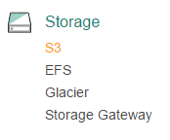

You will be placed in the S3 console.

2. From the S3 console, click the blue **+** **Create Bucket** button:

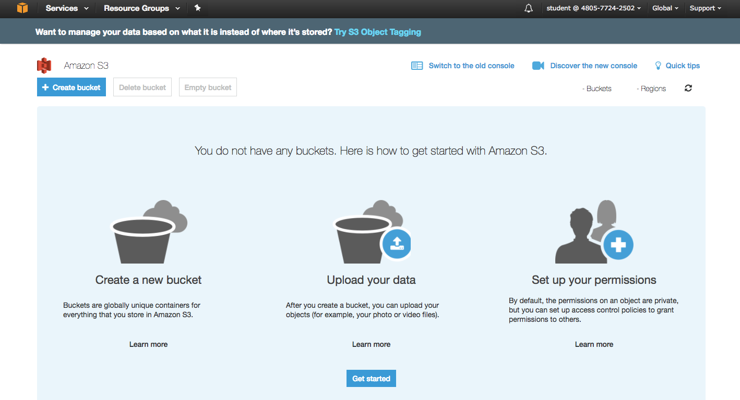

A four part **Create bucket** wizard starts. Screen 1 of 4 is for the **Name and region** information.

3. Enter a unique **Bucket name** on the **Name and region** screen of the wizard:

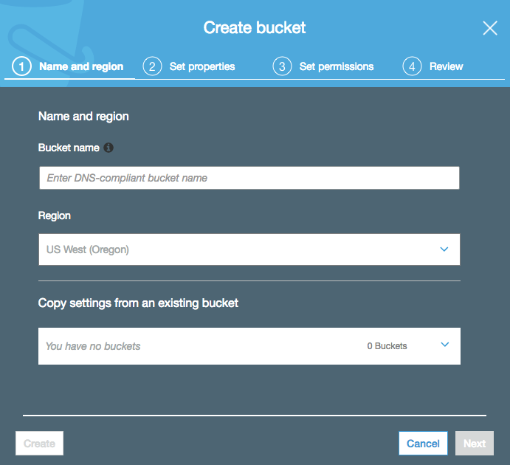

* **Bucket name**: Enter *calabs-bucket-<UniqueNumber>* (Append a unique number to the end of calabs-bucket- Examples: calabs-bucket-3, calabs-bucket-456)
* **Region**: US West (Oregon) (This should be set for you. If not, please select this region.)

***Important!***Bucket names must be globally unique, regardless of the AWS region in which you create the bucket. Buckets must also be DNS-compliant.

The rules for DNS-compliant bucket names are:

* They must be at least 3 and no more than 63 characters long.
* They may contain lowercase letters, numbers, periods, and/or hyphens. Each label must start and end with a lowercase letter or a number.
* They *cannot* be formatted as an IP address (for example, 192.168.1.1).

The following examples are valid bucket names: calabs-bucket-1, cloudinfopulse.bucket , calabs.1 or ca-labs-bucket.

*Troubleshooting Tip*: If you receive an error because your bucket name is not unique, append a different unique number to the bucket name in order to guarantee its uniqueness:

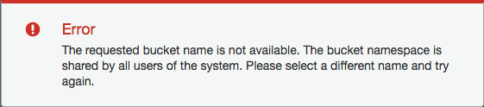

For example, change "calabs-bucket" to "calabs-bucket-1" (or a unique number/character string) and try again.

4. Click **Next** to advance the wizard to the **Set properties** screen: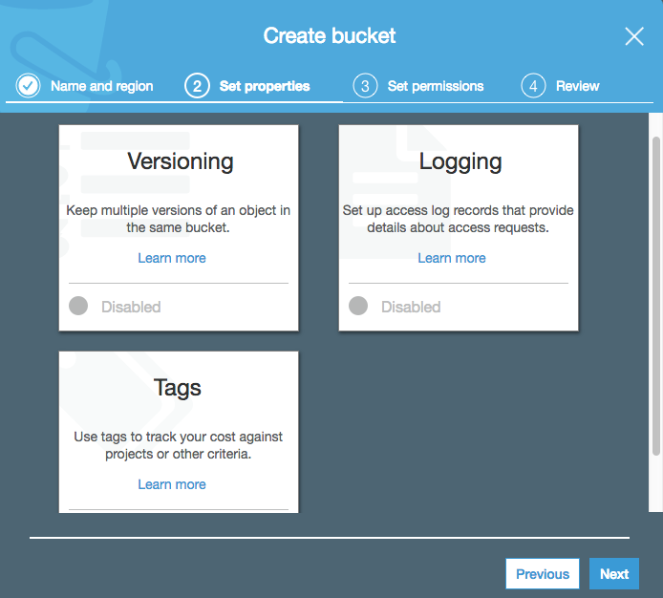

No changes are needed. However, note this is where you can configure both **Versioning** and **Logging** information for your bucket. Additional charges may apply if you enable these features. Please leave them disabled.

5. Click **Next** to advance the wizard to the **Set permissions** screen:

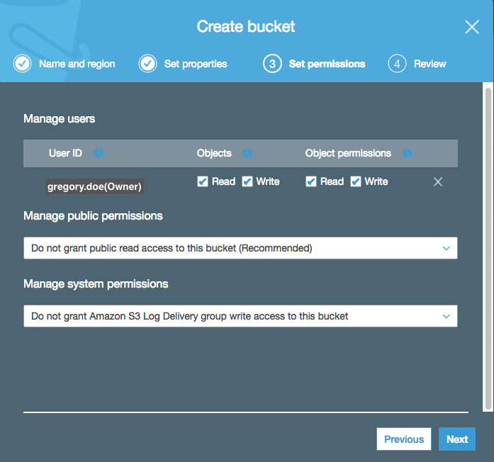

This is where you can set more granular permissions tied to your S3 objects, including public read permission.

6. Click anywhere in the **Manage public permissions** field, then select **Grant public read access to this bucket**:

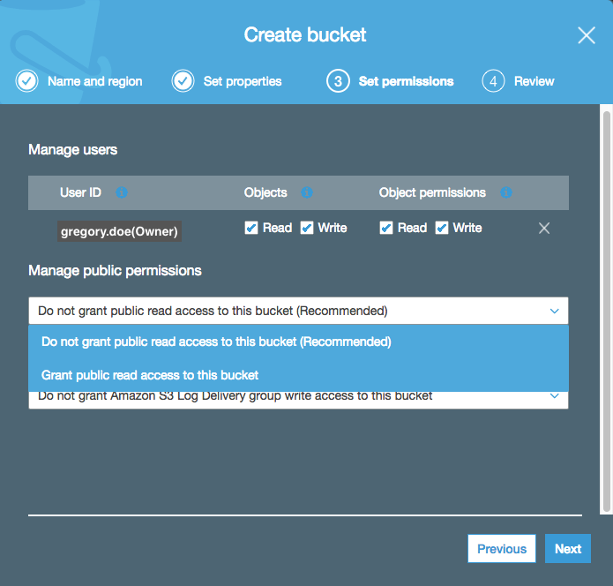

In many instances granting public read access is a security risk, so Amazon will warn you:

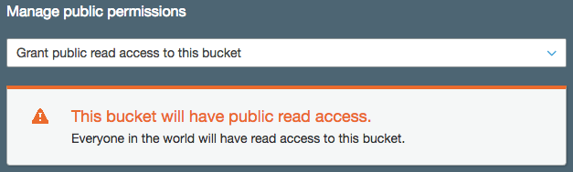

In this case, you want a publicly available website so it is ok to ignore the warning and continue.

7. Click **Next** to advance the wizard to the **Review** screen:

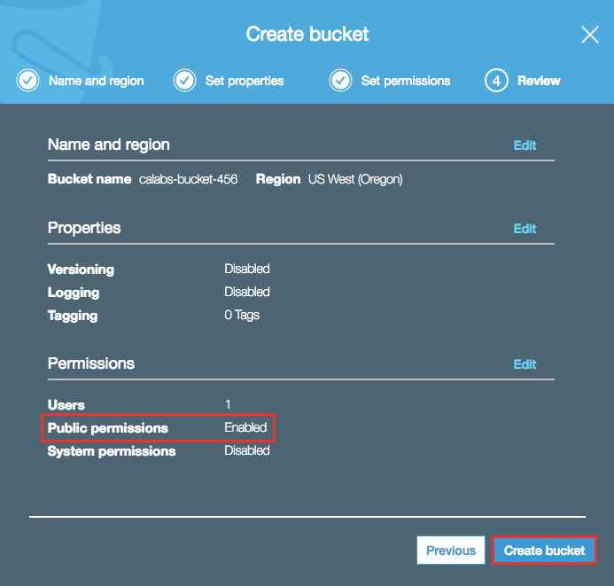

Look over the summary of your bucket configuration and click **Create bucket** when ready to proceed. At this point, you have a S3 bucket with public read access.

8. Select your new bucket then click **Properties** to switch to the **Properties** tab for your new bucket:

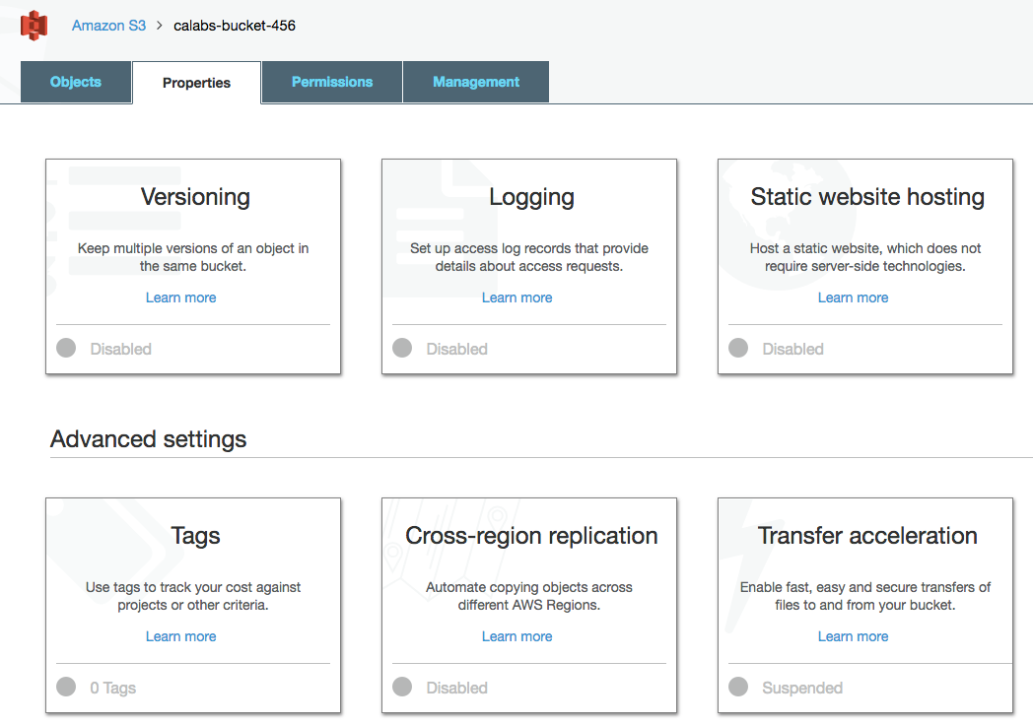

9. Click the **Static website hosting** tile. By default, static website hosting is disabled.

10. Click **Use this bucket to host a website**, then fill out:

* **Index document**: Enter *index.html*
* **Error document**: Enter *error/index.html*

Click **Save** when ready to proceed. Your S3 bucket is ready to host content. Rather than manually changing permissions on multiple objects in your bucket, next you will create a bucket policy. The policy will apply to all objects uploaded to your bucket.

11. Navigate to the **Permissions** tab of your bucket, then click **Bucket Policy:**

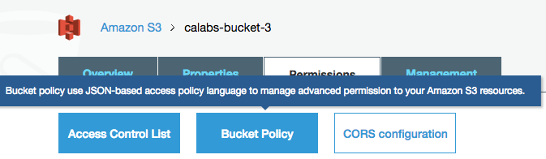

The policy is JSON based.

12. Copy and paste the following into your **Bucket policy editor**:

{  
   "Version": "2012-10-17",  
   "Statement": [  
      {  
         "Sid": "AddPerm",  
         "Effect": "Allow",  
         "Principal": "*",  
         "Action": "s3:GetObject",  
         "Resource": "arn:aws:s3:::*YOUR_BUCKET_NAME*/*"  
      }  
  ]  
}

Be sure to substitute your actual S3 bucket name for **YOUR_BUCKET_NAM**E above. Click **Save** when ready to proceed. The JSON policy will allow public access to all objects beneath your S3 bucket. (Again, this is a very gratuitous policy. Your production policies may differ for security reasons.)

Next you will download a basic website from a public GitHub repository and load it into your S3 bucket.

13. Download a zip file of a basic website provided for you from the Triangu in S3 bucket. Extract the contents of the zip archive to your local file storage.

14. From the top-level of your S3 bucket, click **Upload**. Navigate to where you placed the sample website content. Select or drag and drop all folders and files and click **Upload**. For example:



The permissions on all files and folders uploaded to your S3 bucket will allow public read access.

15. Verify that you uploaded three top-level folders (assets, error, images) along with 3 top-level files as well (index.html, License, Readme) to your S3 bucket. It should look similar to the following:

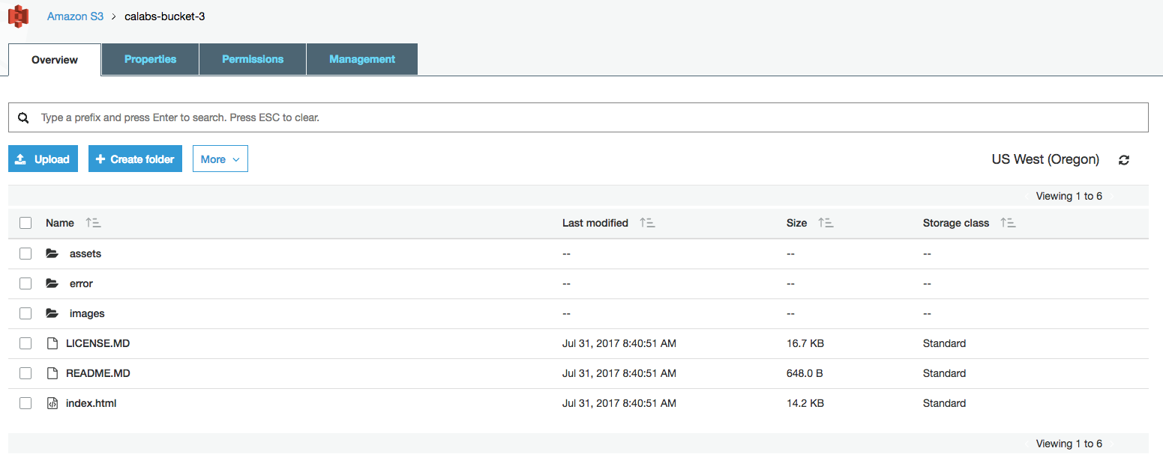

It's time to test everything out.

16. Open a new browser window (or tab) and navigate to the endpoint for your S3 static website.

*Reminder*: You can find the endpoint in the S3 console by navigating to your S3 bucket > **Properties** tab > **Static website hosting** tile (the endpoint is at the top).

The website should look similar to the following:

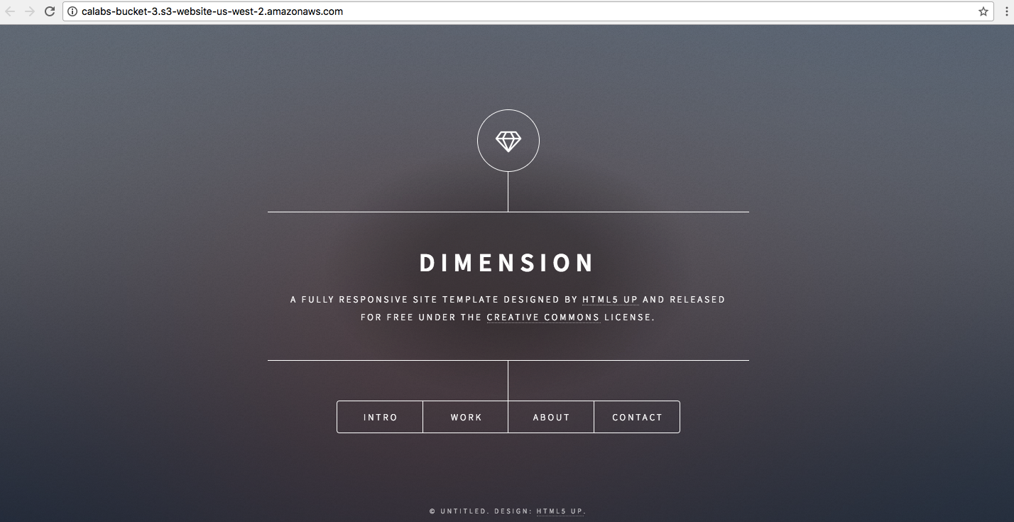

*Note*: The URL for your static S3 website endpoint will differ.

### Summary

In this Lab Step you created an S3 bucket. You configured your S3 bucket to be a static website. You also established a bucket policy to apply to all objects uploaded to your bucket. Finally, you uploaded basic website content and confirmed that it was accessible on the web. At this point, you could simply maintain and use the basic website, or configure a content distribution network (CDN) such as Amazon CloudFront to allow global low-latency access to your website.

## Create a CloudFront Distribution For The Static Website

### Introduction

Amazon CloudFront provides a global content delivery network (CDN) that delivers data in a secure, efficient manner. CloudFront pushes access to your websites out to the edge of the network, thereby reducing latency as access from different global locations is reduced. In this Lab Step you will setup a distribution for a previously created S3 static website.

This Lab Step is not complicated, however, it is often misconfigured due to the way S3 static websites and CloudFront distributions are integrated. The confusion occurs because both S3 and CloudFront have several configuration settings that define their behavior. The S3 static website provides some additional features on the buckets used. For example, by using S3 static websites instead of the default URL for buckets, you can set your own error page and display a friendly message to your users. You can also make use of pretty URLs such as "/blog", or "/about" rather than pointing directly to HTML files. However, even if the static website is configured for your bucket, if you point the CloudFront distribution to the main URL of your bucket and *not* to the website URL, you will end up with the CloudFront default behavior which won't allow pretty URLs and will throw its own error pages configured in the CloudFront console.

### Instructions

1. Navigate to the **Services > Networking & Content Delivery > CloudFront** console:

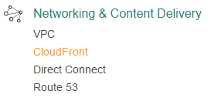

2. Click on the **Create Distribution** button:

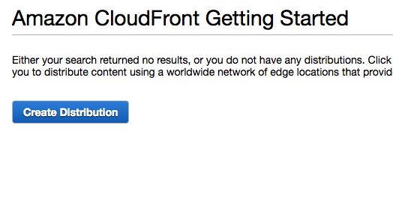

3. Click **Get Started** to create a **Web** distribution:

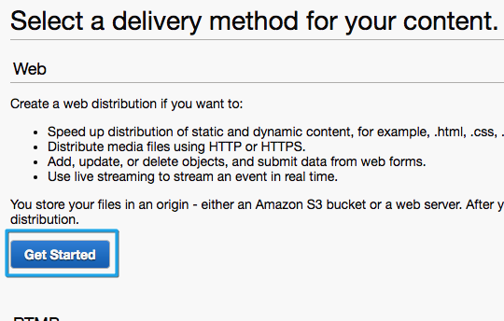

4. On the **Create Distribution** page, for **Origin Settings**, paste the Amazon S3 static website hosting endpoint that you created earlier.

*Hint*: You can obtain the endpoint by navigating to the S3 Console and selecting your bucket > **Properties** tab > **Static website hosting**. Example endpoint - http://calabs-bucket-3.s3-website-us-west-2.amazonaws.com:

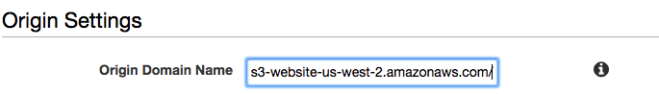

5. Leave all other settings at their default values and click **Create Distribution**. The distributiion process starts and the **Status** is changed to **In Progress**:

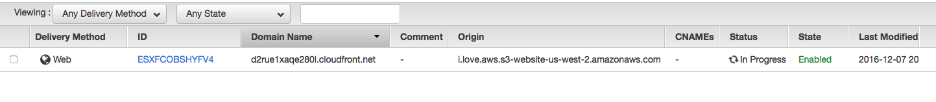

The process typically takes about 15 minutes. The **Status** changes to **Deployed** once the CDN is deployed and ready for use.

6. While you wait for your CloudFront distribution to go online, return to the CloudFront console and click **Create Distribution**. Click **Get Started** for a Web distribution again. Click on the "**i**" information icon for each field that interests you or you are not sure what it might mean:

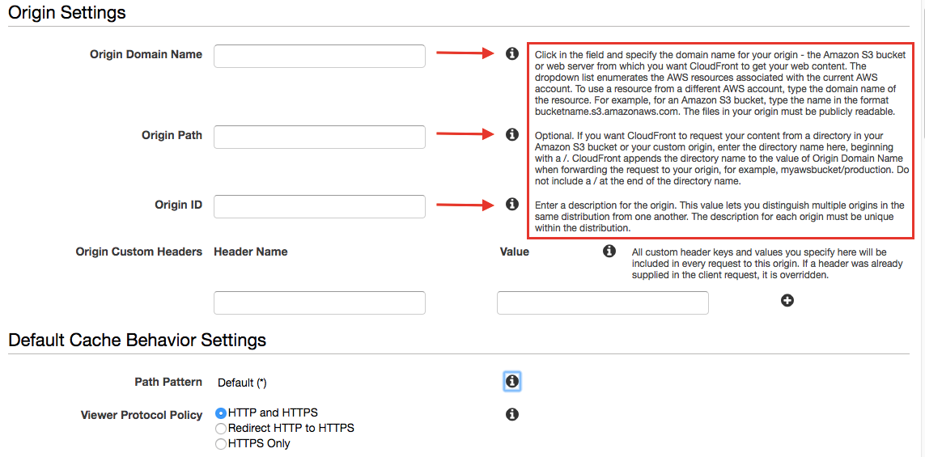

The context sensitive help text provides quick, informative descriptions for each field. Spend a few minutes looking over the descriptions. When through, click **Cancel** and return to the CloudFront console.(Another CloudFront distribution is not needed.)

Once the deployment is completed you can continue with the Instructions below.

7. Click the actionable, random alphabetic **ID** of your CloudFront distribution. The **General** tab is displayed:

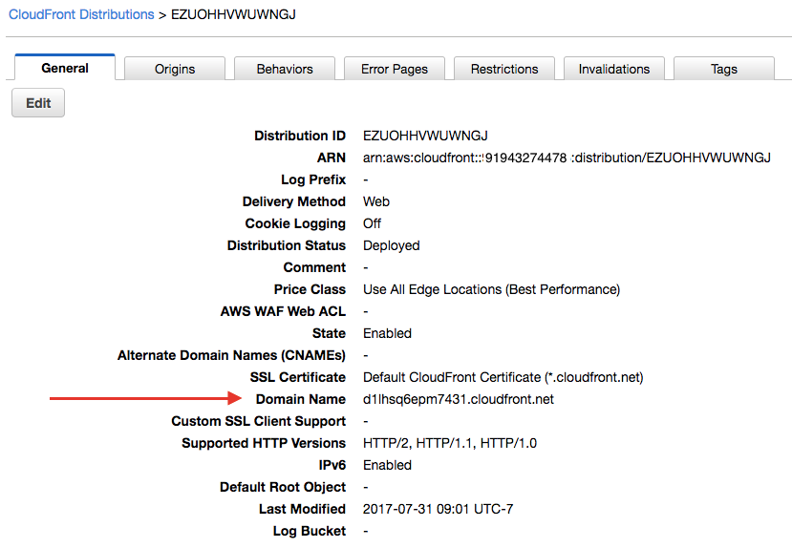

8. Copy the **Domain Name** and paste it into a separate browser window or tab. You should see the same website from the S3 static website previously created:

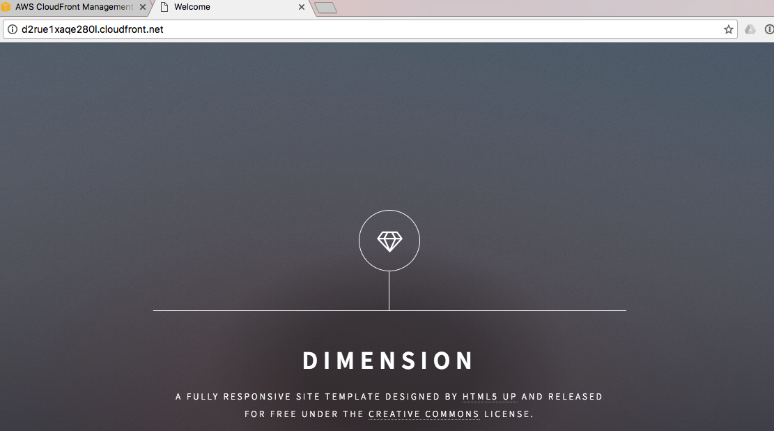

Navigating the website from either CloudFront or the S3 static website URL will generate traffic that is captured for you by Amazon.

*Note*: The Instructions below are optional, perform them if there is enough lab time left and interest permitting.

9. Spend a few minutes navigating the website. Open more than one browser type. (For example, navigate the website with both Safari and Chrome, or whatever other type of browser you have already installed.)

10. Open the **Viewers** page from the left navigation pane, then click the **Browsers** tab:

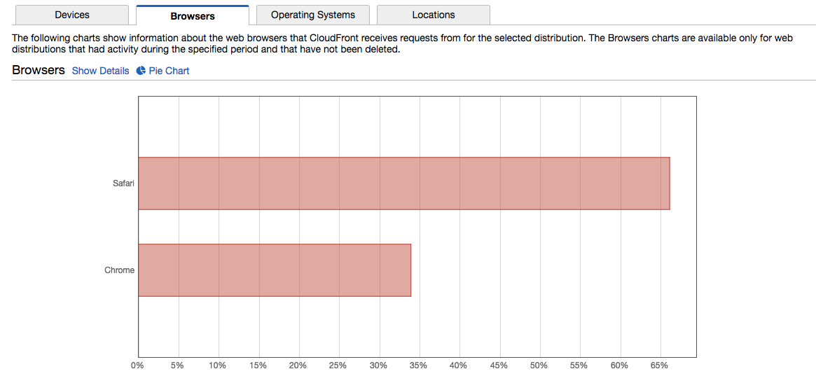

Each browser that you navigated the website with should be captured. (*Note*: There is a variable delay, often about 15 minutes.)

11. Click Pie Chart above the bar graph to switch display types:

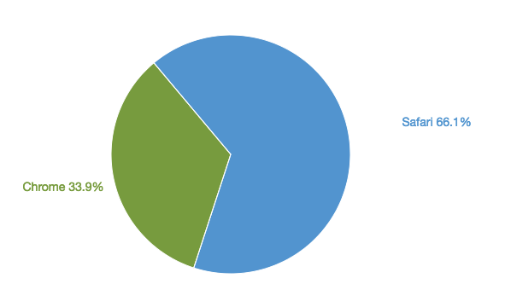

Of course, there are other analytics at your disposal captured by CloudFront, such as the type of device (desktop or mobile), operating system, location (country) of access, and so on. Most of the data is collected and made available on a daily basis, but the granularity can be turned up to hourly for some types of data.

### Summary

Congratulations! You have created a static S3 website accessible to the world with low latency due to a deployment using Amazon CloudFront CDN.